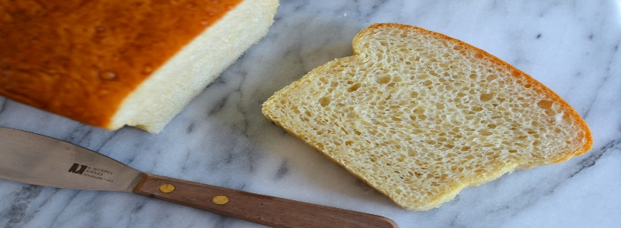

Let’s Make Sandwiches!
Materials Needed:
Sandwich Bags (12)
One Loaf of Bread
1 Package of Cheese (12 Slices)
Country Crock (Butter spread NO MAYO)
Bologna – 1 1/4 Pound of Bologna
Knife/Spreader
Prayer of Thanksgiving for our Food that we are able to Share
Note Card for Recipient (optional)

Directions:
Remove Bread from Package (SAVE BAG AND TIE )
Place Once Slice of Cheese and Two Slices of Bologna on a slice of Bread
Butter Spread a Slice of Bread
Assemble into a sandwich
Cut in half
Place in a sandwich bag
Repeat until all slices of bread have been used.
Place all individual sandwiches back into the original package and tie.
Drop off loaf of sandwiches in the deck box outside the parish office.
Good and Gracious God, Thank you for the abundance of food we share each day and especially the feast of food on Thanksgiving. Bless this food, those who are preparing it and those who will be receiving it. May you continue to provide for all of your children each and every day. Amen.

