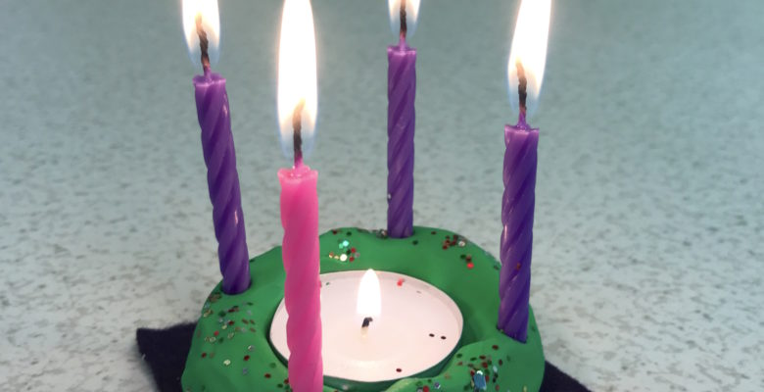
Advent Wreath Craft for Kids

Materials Needed:
Green Clay (2 oz)
1-Tea light candle,3-Purple (Birthday Candles),1-Pink (Birthday Candle)
Glitter

Directions:
Form the green clay into a circle with an opening in the center(like a donut)
Place the tealight candle in the center.
Sprinkle and press in the glitter around the “wreath of clay”
Place each birthday candle in each corner of the “wreath of clay”
Use these prayers from the beginning of Advent until Christmas Eve.
Week 1
Light: One purple candle
Pray: Loving God, thank you for the light.
Help us help the light grow. Amen.
Blow it Out!

Week 2
Light: Two purple candles
Pray: Faithful God, thank you for faith.
Help us make our faith grow. Amen.
Blow it Out!
Week 3
Light: Two purple candles and the pink candle
Pray: Joyful God, thank you for joy. Help us make Joy grow. Amen.
Blow it Out!
Week 4
Light: Purple and Pink candles
Peaceful God , thank you for peace.
Help us to help peace grow. Amen.
Blow it Out!
Christmas Eve
Light: Purple and Pink Candles and the Tealight candle
Living God, thank you for coming to us as a baby. Help us to live with light, faith, joy and peace. Amen.
Blow it Out!
SHOUT: MERRY CHRISTMAS – Hallelujah! He IS BORN!

