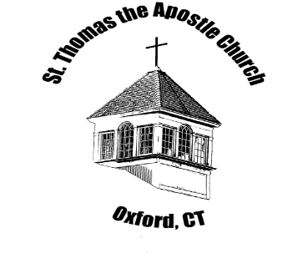
Greetings Everyone!
Welcome Back to Faith Formation and Confirmation Preparation at St. Thomas the Apostle Church.
Freshman year is a time of great change, a different school, a new social climate, more accountability for individual actions, and time becomes a valuable commodity which there isn’t enough of.
Our sacramental team is prepared to guide our candidates to mature in their faith, gain personal responsibility and become active participating members of our parish community. It is our hope that they will continue to make great strides in their faith development and in their commitment to the sacramental process. Throughout the summer we have been preparing a comprehensive program that allows young people to witness our faith in action.
Confirmation preparation time is an opportunity for all of us to grow closer to Jesus. Recall the story of Jesus on the Road to Emmaus. This story shows how our faith is transmitted by:
- Walking
- Talking, and
- Sharing the Faith
Just as Jesus walked and talked with his disciples so we should be talking with our teens about God and our Catholic Faith. We know that this can be a sensitive topic at this stage of their lives, however, it is an important one for our young people.
As primary religious educators of the faith, share with your children in an open and honest manner stories of your own personal growth in your faith. This will help your family grow together in faith.
It is our pleasure to serve you and walk with you as we journey together toward a deeper understanding of how the Holy Spirit works in our lives and in the life of the Church, and a deeper appreciation of how being open to the presence and actions of the Holy Spirit in our lives can draw us to a closer relationship with our Lord Jesus.
The Confirmation Team
Jennifer Mahmood- Sacramental Preparation Director
Sue Kondic - Mentor
Wanda Mascola- Director of Faith Formation

